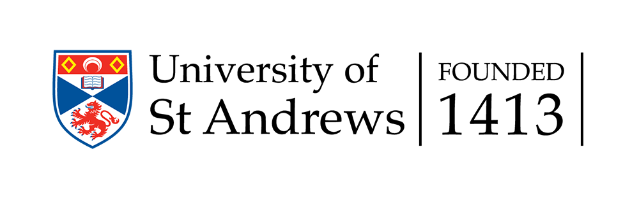
School of Management

Contemporary Issues in Banking Conference

Programme and abstracts
8th - 9th December 2015

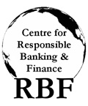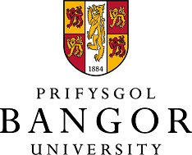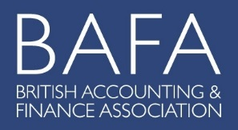
Contemporary Issues in Banking Conference

Tuesday 8th December 2015
Time | Item | Authors | Discussant | Chair
12.15 - 13.00 | Registration & Sandwiches/Tea/Coffee
13.00 - 13.05 | Welcome and Introduction | John Wilson  (University of St Andrews)
 | Session I |  |  | Claudia Girardone  (Essex University)
13.05 – 13.40 | Curbing Systemic Risk in the Insurance Sector: a Mission Impossible? | Paola Bongini  (University of Milan-Bicocca)  Laura Nieri  (Università di Genova)  Matteo Pelagatti  (University of Milan-Bicocca)  Andrea Piccini  ( State Street Bank Luxembourg ) | Dimitris Chronopoulos  (University of St Andrews)
13.40 – 14.15 | The Effect of Accounting Standards on Loan Loss Provisioning in  Banks | Jan Marton  (University of Gothenburg)  Emmeli Runesson  (University of Gothenberg) | Louis Nguyen  (University of St Andrews)
14.15 – 14.50 | Financial Crisis and International Supervision: New Evidence on the Discretionary Use of Loan Loss Provisions at Euro Area Commercial Banks | Domenico Curcio  ( University of Naples "Federico II")  Antonio De Simone  (University of Naples "Federico II")  Angela Gallo  (Università degli Studi di Salerno) | Yizhe Dong  (Aberystwyth University)
14.50 – 15.20 | Tea/Coffee
 | Session II |  |  | Barbara Casu  (Cass Business School, City University London)
15.20 – 15.55 | Bank Transparency and the Crisis | Panayotis Manganaris  (Aristotle University of Thessaloniki)  Elena Beccalli  (Università Cattolica del Sacro Cuore and London School of Economics)  Panagiotis Dimitropoulos  (University of Peloponnese) | Linh Nguyen  (University of St Andrews)
15.55 - 16.30 | Corporate Debt Restructuring, Bank Competition and Stability: Evidence from Creditors’ Perspective | M. Mostak Ahamed  (Queen Mary University)  Sushanta Mallick  (Queen Mary University) | Andrea Paltrinieri  (University of Verona)
16.30 – 17.05 | Capital and Liquidity Ratios and Financial Distress: Evidence from the European Banking Industry | Laura Chiaramonte  (Università Cattolica del Sacro Cuore)  Barbara Casu  (Cass Business School, City University London) | Donal McKillop  (Queen’s University of Belfast)
17.05-17.40 | A Sustainable Business Model Strategy for Irish Credit Unions: Does One Size Fit All? | Donal McKillop  (Queen’s University of Belfast)  Barry Quinn  (Queen’s University of Belfast) | Federica Poli  (Università Cattolica del Sacro Cuore)

Wednesday 9th December 2015

Time | Item | Authors | Discussant | Chair
 | Session III |  |  | Ross Brown  (University of St Andrews)
09.00 -09.35 | Unsolicited Sovereign Ratings and The Sovereign-Bank Ceiling: An Unintended Consequence of Regulatory Disclosure | Patrycja Klusak  (University of East Anglia)  Rasha Alsakka  (Bangor University)  Owain ap Gwilym  (Bangor University) | Pejman Abedifar  (University of St Andrews)
09.35 - 10.10 | Carrying the (Paper) Burden: A Portfolio View of Systemic Risk and Optimal Bank Size | Jaap Bos  (Maastricht University)  Martien Lamers  (University of Groningen)  Victoria Purice  (Ghent University) | Jose Linares Zegarra  (Essex University)
10.10 - 10.30 | Tea/Coffee
10.30-11.45 | Keynote Session |  |  | Phil Molyneux  (Bangor University)
Keynote Speech | When Do Laws and Institutions Affect Recovery Rates on Collateral? | Hans Degryse  (KU Leuven)

 | Session IV |  |  | Elena Beccalli  ( Università Cattolica del Sacro Cuore and London School of Economics)
11.50 – 12.25 | Governance, Efficiency and Risk-Taking in Chinese Banking | Yizhe Dong  (Aberystwyth University)  Claudia Girardone  (Essex University)  Jing-Ming Kuo  (Southampton University) | Kais Bouslah  (University of St Andrews)
12.25 -13.00 | The Price, Quality and Distribution of Mortgage Payment Protection Insurance | John Ashton  (Bangor University)  Robert Hudson  (Hull University) | Leonidas Barbopoulos  (University of St Andrews)
13.00 - 13.15 | Closing Remarks | John Wilson  (University of St Andrews)
13.15 - 14.15 | Lunch

