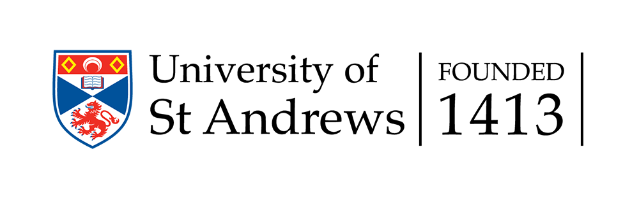
School of Management

2nd Conference on
Contemporary Issues in Banking

12th - 13th December 2017

Programme

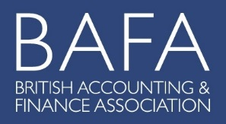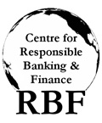

Tuesday 12th December 2017

09.00 - 09.30 | Registration & Tea/Coffee
09.30 - 09.40 | Welcome and Introduction | John Wilson (University of St Andrews)
Session I
Time | Title | Chair: John Wilson (University of St Andrews) | Discussant
09.40 – 10.20 | Use it or lose it. Credit lines and liquidity risk management | Barbara Casu (Cass Business School)  Laura Chiaramonte (Università Cattolica del Sacro Cuore)  Ettore Croci (Università Cattolica del Sacro Cuore)  Stefano Filomeni (University of Essex) | Ivan Lim (University of Leeds)
10.20 – 11.00 | Whatever it takes: Cross-border spillovers of a major central bank intervention | Carlo Alcaraz (Central Bank of Mexico)  Stijn Claessens (Federal Reserve Board)  Gabriel Cuadra (Central Bank of Mexico)  David Marques-Ibanez (European Central Bank)  Horacio Sapriza (Federal Reserve Board) | Charles Nolan (University of Glasgow)
11.00-11.40 | Does Bank Supervision Matter? Evidence from Regulatory Office Closures | Ivan Lim (University of Leeds)  Jens Hagendorff (University of Edinburgh)  Seth Armitage (University of Edinburgh) | Linh Nguyen (University of St Andrews)
11.40 – 12.00 | Tea/Coffee
Session II
Time | Title | Chair: Barbara Casu (Cass Business School) | Discussant
12.00 – 12.40 | Do Small Banks Alleviate Households’ Financial Constraints? – Surprising Evidence from the University of Michigan Surveys of Consumers | Allen N. Berger (University of South Carolina)  Felix Irresberger (University of Leeds)  Raluca A. Roman (Federal Reserve Bank of Kansas City) | Pejman Abedifar (University of St Andrews)
12.40 - 13.20 | (Simple)- Securitization and Bank Liquidity Management: Evidence from US Corporate Lending Market | Angela Gallo (Cass Business School)  Min Park (University of Exeter) | David Marques-Ibanez (European Central Bank)
13.20 – 14.20 | Lunch
Tuesday 12th December 2017

Session III
Time | Title | Chair: Ross Brown (University of St Andrews) | Discussant
14.20 – 15.00 | Political Connections: Evidence from Insider Trading around TARP | Ozlem Akin (Ozyegin University)  Nicholas S. Coleman (Federal Reserve Board)  Christian Fons-Rosen (Universitat Pompeu Fabra)  Jose-Luis Peydro (Universitat Pompeu Fabra, ICL) | Dimitris Andriosopoulos (University of Strathclyde)
15.00 - 15.40 | Which Banks Smooth Shocks? | Sotirios Kokas (University of Essex)  Dmitri Vinogradov (University of Glasgow)  Marios Zachariadis (University of Cyprus) | Theodoros Diasakos (University of Stirling)
15.40 – 16.00 | Tea/Coffee
Session IV
Time | Title | Chair: Claudia Girardone (University of Essex) | Discussant
16.00 – 16.40 | Does going easy on distressed banks help economic growth? | Sean Hundtofte (Federal Reserve Bank of New York) | Donal McKillop (Queen's University Belfast)
16.40 - 17.20 | Regulatory Spillovers in Common Mortgage Markets | Ivan Lim (University of Leeds)  Duc Duy (Louis) Nguyen (University of St Andrews)  Linh Nguyen (University of St Andrews) | Angela Gallo (Cass Business School)

Wednesday 13th December 2017

Session V
Time | Title | Chair: Daniel Oto Peralias (University of St Andrews) | Discussant
09.00 - 09.40 | Does Excess Cash Affect Bank Behavior? | Elena Beccalli (Università Cattolica del Sacro Cuore)  Laura Chiaramonte (Università Cattolica del Sacro Cuore)  Ettore Croci (Università Cattolica del Sacro Cuore) | Leonidas Barbopoulos (University of Glasgow)
09.40 - 10.20 | Cryptocurrencies from an Austrian perspective | Alistair Milne (Loughborough University) | José Liñares-Zegarra (University of Essex)
10.20 - 11.00 | What causes bank bailouts? The role of gender diversity | Giovanni Cardillo (University of Bologna)  Enrico Onali (Aston University)  Giuseppe Torluccio (University of Bologna) | Claudia Girardone (University of Essex)
11.00 - 11.20 | Tea/Coffee
Session VI
Time | Title | Chair: Elena Beccalli (Università Cattolica del Sacro Cuore) | Discussant
11.20 -12.00 | Bank Credit Ratings, Capital Structure Adjustments and Lending | Claudia Girardone (University of Essex)  Alex Sclip (University of Udine) | Dimitris Chronopoulos (University of St Andrews)
12.00 - 12.40 | Hidden effects of bank recapitalizations | Elena Beccalli (Università Cattolica del Sacro Cuore)  Pascal Frantz (London School of Economics)  Francesca Lenoci (Università Cattolica del Sacro Cuore) | Maria Iannino (University of St Andrews)
12.40 - 13.00 | Closing Remarks | John Wilson (University of St Andrews)
13.00 - 14.00 | Lunch

