Hopin Guide
Contents
Accessing Hopin – for all 1
Using Hopin – what you need to know 1
Preparing to join Hopin 1
Sharing your PowerPoint presentation 2
Using the Moderator panel 2
Who is listening? 3
Troubleshooting. 3
Some attendees can hear you, but one or two cannot. 3
You cannot share your audio or video 3

Accessing Hopin – for all

- Email one – ‘Invitation to event’ – this email will include an ‘Accept registration’ button. This must be accepted as soon as possible.
- Registration accepted if you are a moderator you will be added to your session
- Email two – ‘Registration confirmation’ – use this email to add the event to your calendar, or save it for fast access to the event on the day
Panel chairs are added to Hopin as Moderators. This means that you control access to your session, and that you can immediately share your video and audio without requesting permission.

Using Hopin – what you need to know
Preparing to join Hopin
Remember always to use Chrome or Firefox with Hopin.
Hopin does not allow for background blurring, so please be aware of your background.
If you have a presentation to share, have this open on your desktop before joining. This makes the sharing operation much more straight-forward.
Ensure that your browser and computer are set to share audio and video and they are ready to use. Shut down other apps if sharing audio/video.

Sharing your PowerPoint presentation
Hopin have done an incredibly detailed and useful guide on how to share a presentation, which can be found here.
If you follow the instructions on this guide, you will be able to share your PowerPoint while viewing the questions that come in. There are separate instructions for Macs or PCs.

Using the Moderator panel
Moderators have to allow those in their session to share their video and audio (i.e. be seen and heard by all):
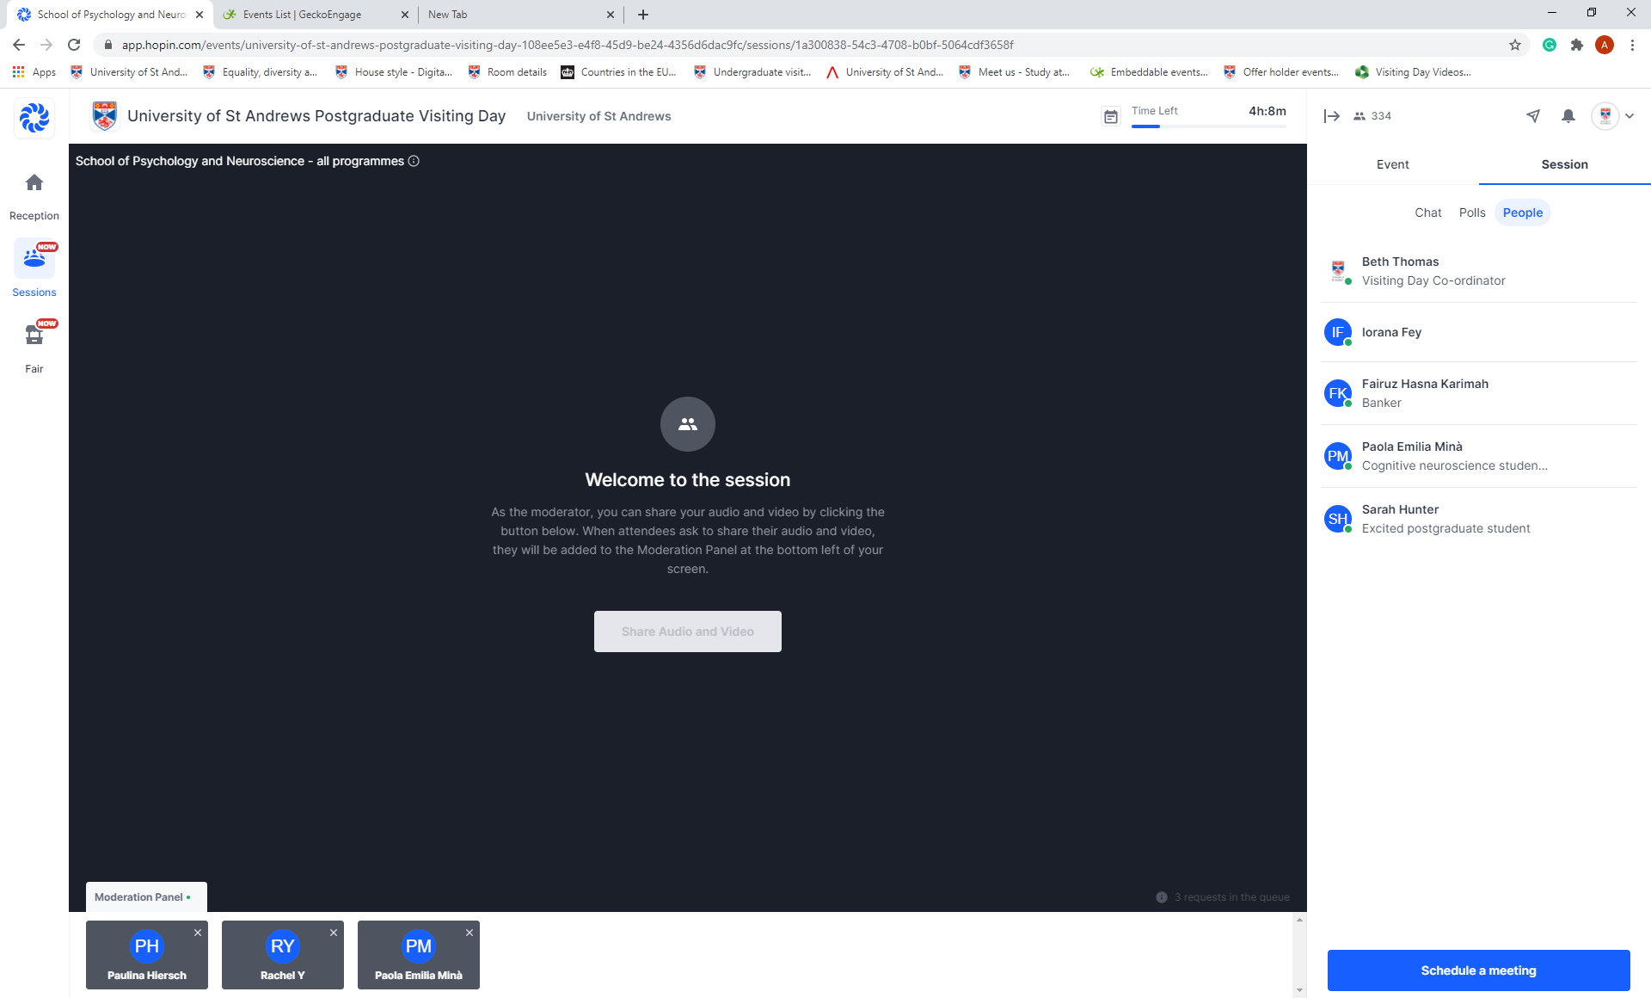
Requests will pop up in the Moderation panel – click on a name or set of initials to allow them to join. They can then share their screen to show a powerpoint as per above instructions.
During the Q&A portion of your session, if you have one, you may find that you wish to invite attendees to share their screen and audio with you so that you can talk, rather than just answer the chat.
Note: there is a limit of 20 as to how many can be on screen at once. This is to preserve bandwidth.

Who is listening?
To find out how many people are in your session in total (including you), you can use the ‘eye’ at the top of the screen:
To find out who the people are, go to the ‘people’ tab under ‘session’
This will provide you with a full list of the people who are still present in your stand.

Troubleshooting.

Some attendees can hear you, but one or two cannot.
This is due to the attendee’s browser or internet. Leaving and returning again is the best way to solve this issue.

You cannot share your audio or video as a moderator
If you join a session and see ‘ask to share audio and video’, this means you are not marked as a moderator. Send a message to the conference organisers and they can add you as a moderator.

